**LAB # 1**



**CSE-203L Circuit & Systems-II Lab**

**Fall 2022**

Submitted by: Ali Asghar

Registration No.: **21PWCSE2059**

Class Section: **C**

“On my honor, as student of University of Engineering and Technology, I have neither given nor received unauthorized assistance on this academic work.”

Student Signature: ______________

Submitted to:

**Engr. Faiz Ullah**

11th October, 2022

Department of Computer Systems Engineering

**TITLE:**

**The Oscilloscope**

**OBJECTIVES:**

* To get introduced to the use of the oscilloscope
* To learn about the practical nature of oscilloscope.
* To examine the various input scaling, coupling, and triggering settings along with few specialty features.
* To learn about input scaling, coupling and triggering settings which are examined though some specific features.

**APPARATUS:**

* DC Power Supply
* AC Function Generator
* Digital Multimeter
* Oscilloscope
* 2 x Resistors(R1 = 9.7K & R2 = 2.4k)
* Connecting Wires
* Breadboard

**Oscilloscope**:

An oscilloscope (or a scope) is a type of [electronic test instrument](https://en.wikipedia.org/wiki/Electronic_test_instrument) that graphically displays varying electrical [voltages](https://en.wikipedia.org/wiki/Voltage) as a two-dimensional plot of one or more signals as a function of time.

**CATHODE RAY OSCILLOSCOPE (CRO):**

The cathode ray oscilloscope (CRO) is a type of electrical instrument which is used for showing the measurement and analysis of waveforms and other electronic and electrical phenomena. It is an extremely quick X-Y plotter that shows the input signal versus another signal or versus time. The CROs are used to analyze the waveforms, transient, phenomena, and other time-varying quantities from an extremely low-frequency variety to the radio frequencies.

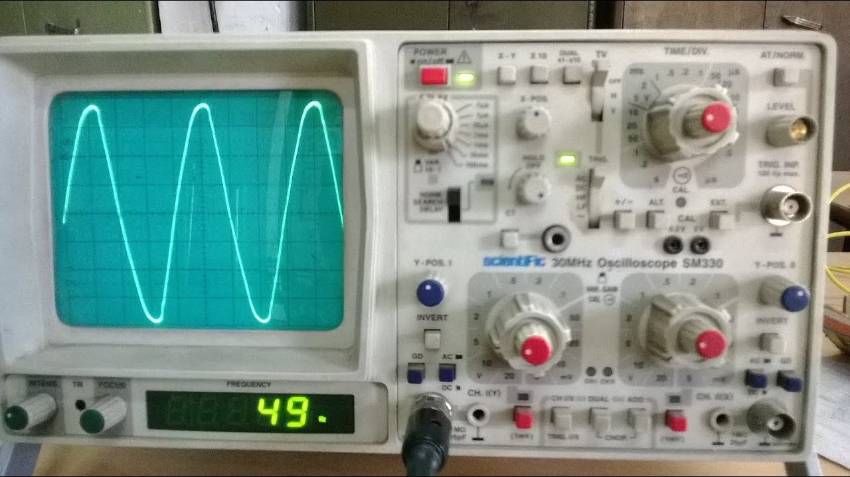

Cathode Ray Oscilloscope (CRO):

**CONSTRUCTION OF CRO:**

The building of CRO consists of the following:

* Cathode Ray Tube
* Electronic Gun Assembly
* Deflecting Plate
* Fluorescent Screen For CRT
* Glass Envelop

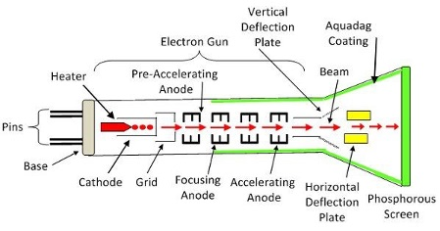

**MAIN FEATURES:**

* [Size and portability](https://en.wikipedia.org/wiki/Oscilloscope#Size_and_portability)
* [Inputs](https://en.wikipedia.org/wiki/Oscilloscope#Inputs)
* [Probes](https://en.wikipedia.org/wiki/Oscilloscope#Probes)
* [Front panel controls](https://en.wikipedia.org/wiki/Oscilloscope#Front_panel_controls)
* Basic types of sweeps
* [Dual and multiple-trace oscilloscopes](https://en.wikipedia.org/wiki/Oscilloscope#Dual_and_multiple-trace_oscilloscopes)
* [The vertical amplifier](https://en.wikipedia.org/wiki/Oscilloscope#The_vertical_amplifier)
* Bandwidth

**TYPES OF oscilloscope:**

* [Cathode-ray oscilloscope (CRO)](https://en.wikipedia.org/wiki/Oscilloscope#Cathode-ray_oscilloscope_(CRO))
* Dual-beam oscilloscope
* [Analog storage oscilloscope](https://en.wikipedia.org/wiki/Oscilloscope#Analog_storage_oscilloscope)
* [Digital oscilloscopes](https://en.wikipedia.org/wiki/Oscilloscope#Digital_oscilloscopes)
* [Mixed-signal oscilloscopes](https://en.wikipedia.org/wiki/Oscilloscope#Mixed-signal_oscilloscopes)
* [Mixed-domain oscilloscopes](https://en.wikipedia.org/wiki/Oscilloscope#Mixed-domain_oscilloscopes)
* [Handheld oscilloscopes](https://en.wikipedia.org/wiki/Oscilloscope#Handheld_oscilloscopes)

# MAIN PURPOSE:

The main purpose of the oscilloscope is to plot a voltage versus time, although it can also be used to plot one voltage versus another voltage, and in some cases, to plot voltage versus frequency.

**FUNCTION GENERATOR:**

A function generator is a specific form of signal generator that is able to generate waveforms with common shapes.

In particular it can be made to become a sine wave generator, square wave generator, and triangular wave generator.

A function generator may also be able to vary the characteristics of the waveforms, changing the length of the pulse, i-e the mark space ratio, or the ramps of the different edges of triangular or sawtooth waveforms, but it is only be able to create the waveforms that are built in to the function generator. It cannot be programmed to create additional waveforms - an arbitrary waveform generator, AWG is required for this.

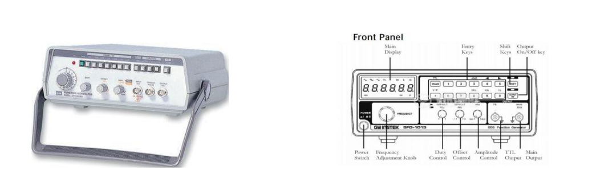

Function Generator

**DIFFERENT WAVEFORMS GENERATED BY FUNCTION GENERATOR:**

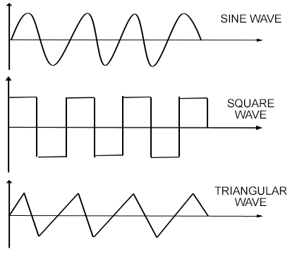

Different Types of Waves

**PROCEDURE:**

**For DC:**

1. First of all, I connected two resistors in series with each other and applied 5V across them.
2. Then I connected the oscilloscope to power supply.
3. I applied all the necessary settings in oscilloscope for a DC circuit and switched from AC to DC with the help of Input coupling.
4. Then I set the channel-1 Vertical Scale to my desired volt per division.
5. I connected the probe from the channel-1 to the power supply and connected tip to plus and black clip to ground.
6. The DC horizontal line on the screen of oscilloscope deflected vertically through certain divisions.
7. Hence the voltage drop can be measured by multiplying **volts per division** with the **number of divisions** jumped.

**For AC:**

1. The circuit is same as it was for DC, except the power supply is now AC.
2. After applying AC power supply from the **function generator**, the settings in oscilloscope were re-arranged for AC supply.
3. The function generator is also set at suitable settings for generating a sine wave in the oscilloscope.
4. Then I connected the circuit with the function generator with the help of clips and then connected the oscilloscope with the help of probes.
5. Lastly, I measured the below values across R1 and R2 with the help of probes.

**OBSERVATIONS AND RESULTS:**

**DC**

**For R1:**

|  |  |  |  |  |
| --- | --- | --- | --- | --- |
|  | Scale (V/Div) | # Of Divisions | Voltage Peak-Peak | Voltage RMS |
| Oscilloscope | 1 | 4.4 | 4.4 V | 4.4 V |
| Theoretical | _________ | _________ | 4 V | 4 V |

**For R2:**

|  |  |  |  |  |
| --- | --- | --- | --- | --- |
|  | Scale (V/Div) | # Of Divisions | Voltage Peak-Peak | Voltage RMS |
| Oscilloscope | 1 | 1.2 | 1.2 V | 1.2 V |
| Theoretical | _________ | _________ | 1 | 1 |

**AC**

**For R1:**

|  |  |  |  |  |
| --- | --- | --- | --- | --- |
|  | Scale (V/Div) | # Of Divisions | Voltage Peak-Peak | Voltage RMS |
| Oscilloscope | 2 | 2.2 | 4.4 V | 3.11 V |
| Theoretical | _________ | _________ | 4 | 2.82 V |

**For R2:**

|  |  |  |  |  |
| --- | --- | --- | --- | --- |
|  | Scale (V/Div) | # Of Divisions | Voltage Peak-Peak | Voltage RMS |
| Oscilloscope | 2 | 0.6 | 1.2 V | 0.85 V |
| Theoretical | _________ | _________ | 1 V | 0.70 V |

**For Frequency and Time Period:**

|  |  |  |  |  |
| --- | --- | --- | --- | --- |
|  | Scale (S/Div) | # Of Divisions | Time Period | Frequency |
| Oscilloscope | 5 ms | 1 | 5ms | 1600Hz |

**CONCLUSION:**

From this experiment, we concluded the oscilloscope is a multi-functional device. It can be used for analysis of various kind of electric circuits. We can measure voltage drop across resistors with the help of oscilloscope. We can plot voltage vs time graph on oscilloscope.